If a point at random is positioned somewhere in the shape below, what is the probability that the point will be within the boundaries of the heart shaped separation.

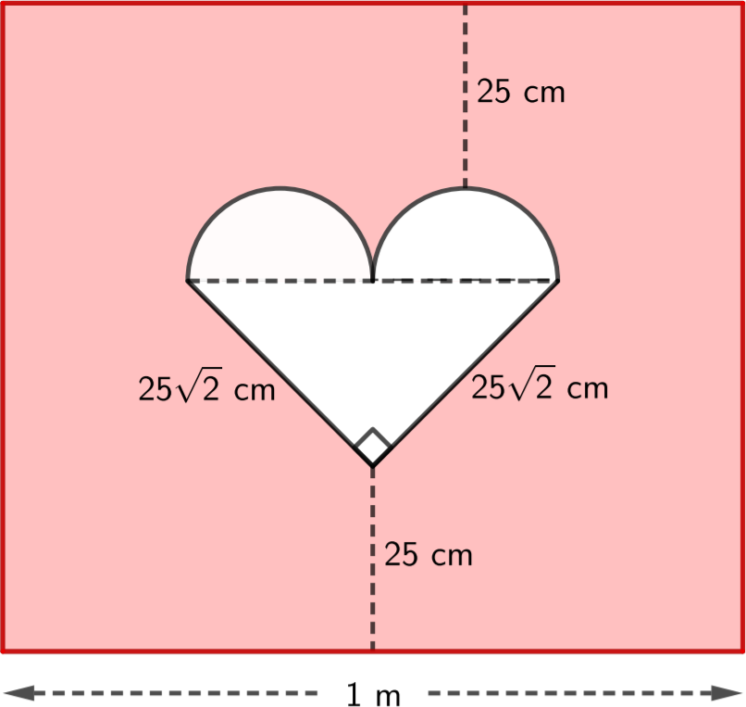

The problem can be modelled by $P=\frac{A_{h}}{A_{t}}⋅100$, where *Ah* is the area of the heart shaped object and *At* is the total area of the rectangle.

*Ah* is equal to the sum of the two regions that compose the heart. The lower rectangular region, and the upper circle region, composed of the two semi circles placed above the triangle.

The area of the triangular region can be determined using $A=\frac{hb}{2}$. $A=\frac{25\sqrt{2}⋅25\sqrt{2}}{2}=625cm^{2}$.

The hypotenuse of the triangular region *c* can be used for the calculation of the circular regions area and the height of the rectangle. It can be determined using Pythagoras, $a^{2}+b^{2}=c^{2}$, in this case $2{\left(25\sqrt{2}\right)}^{2}=c^{2}$, $c=50$.

Because the semicircles are the same size, together they form the circular region. Using the hypotenuse of the triangle we can determine the diameter of the circular region $d=\frac{c}{2}=\frac{50}{2}=25$. Using $A=πr^{2},r=\frac{d}{2}$ we can determine the area of the circle, $A=π{12.5}^{2}=π156.25$.

Finally, the area of the rectangle can be determine using $A=hw$. However, we only have the width value of 100 cm. To determine the height of the rectangle using $h=25+25+h_{t}+\frac{h_{c}}{2}$, where *ht* is the height of the triangle and *hc* is the height of the circle. $h_{t}$ can be found by inscribing a smaller triangle within the primary one. The height of the smaller triangle can be found using Pythagoras, in this case $c^{2}+{\left(\frac{50}{2}\right)}^{2}={\left(25\sqrt{2}\right)}^{2}$, $c=25$. $h_{c}$ can be found as we know the diameter or height of the circle already to be 25 cm. $h=25cm+25cm+25cm+\frac{25}{2}cm=87.5cm$. Finally, the area of the rectangle $A=hw$, is found $A=hw=100cm⋅87.5cm=87500cm$.

Using $P=\frac{A_{h}}{A_{t}}⋅100$, the probability of any given point being within the heart shape can be found. $A_{h}=625cm^{2}+π\frac{625}{4}cm^{2}=625cm^{2}\left(1+π\frac{1}{4}\right)$, $A_{t}=87500cm^{2}$, $P=\frac{625cm^{2}\left(1+π\frac{1}{4}\right)}{8750cm^{2}}⋅100=\frac{4+π}{56}⋅100=\frac{25\left(π+4\right)}{14}=12.752844≈12.75\%$.